Student Grade Management Application

Overview -

User-friendly piece of software called the “Student Grade Management Application”. Its purpose is to assist educational institutions in effectively managing and analyzing student grades. With a variety of capabilities to import data, create reports, and display crucial information, the application offers a straightforward and clear user interface.

Figure 1:  File Browsing

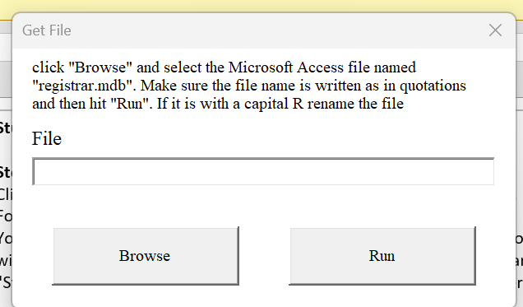

Figure 2: Data Entry

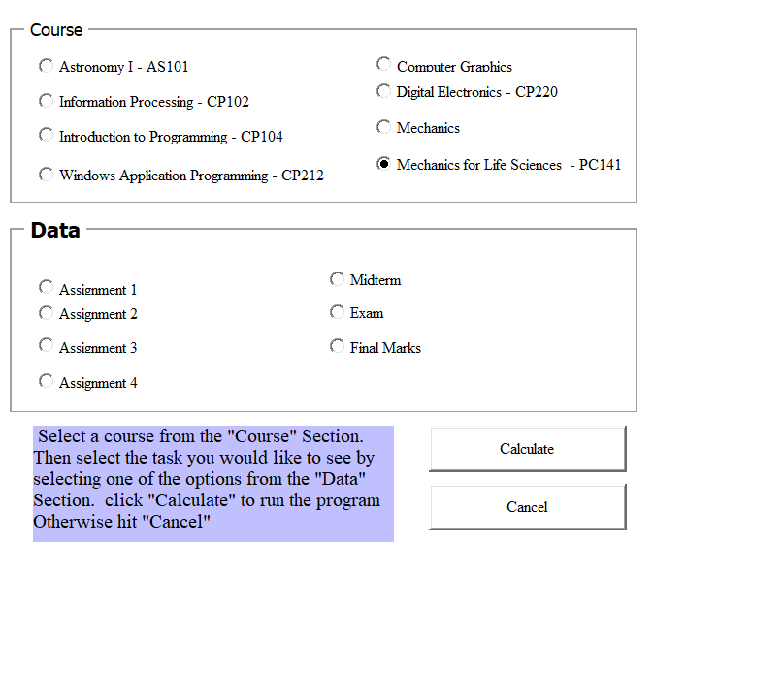

Figure 3: Custom Ribbon Bar

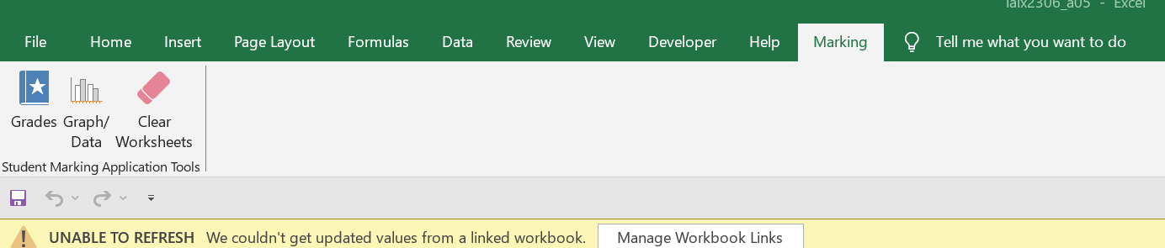

Features -

**Browse Button:**

Users can carry out their chosen activity, such as importing data from the selected database file or creating a report based on student grades, by pressing the "Browse" button.

**Run Button:**

Users have run the file application by clicking the "Run" button.

**Import Data:**

The program features an easy-to-use data import feature. Users can import student grade information from the registrar.mdb database by choosing the "Import Data" radio button and then pressing the "Continue" button. The user will be given the option to select the database file from any place when the application asks them to do so using the FileOpen Dialog.

**Generate Report:**

Once the user has imported the file and inputted what data they need they can click the graph/data button from the custom ribbon

**Calculate:**

By clicking the "Calculate" option, the users can view all the calculations in regard to the user input.

Database and Grade Weightings

The registrar.mdb database, which has three sections (courses, grades, and students), is used by the program. Information like the course ID, course code, and course name can be found in the "Courses" section. Student ID, individual assessment grades (A1, A2, A3, A4), midterm exam results, and final exam results are all included in the "Grades" section. First names, last names, and student IDs are listed in the "Students" section.